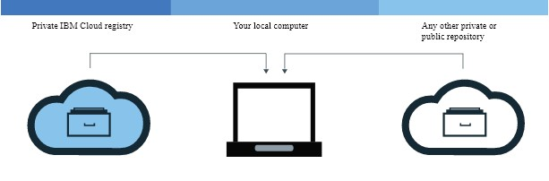

* Install the CLI to work with images in your namespace.
* Set up your own namespace in IBM Cloud Container Registry.
* Pull or build an image on your local computer and tag the image with your namespace information.
* Make sure that you can run Docker commands without root permissions. If your Docker client is set up to require root permissions, you must run ibmcloud login , ibmcloud cr login , docker pull , and docker push commands

with sudo .

|  |
| --- |
| ibmcloud login |

If you change your permissions to run Docker commands without root privileges, you must run the command again.

**To upload (push) an image, complete the following steps:**

PNT2022TMID05962

Log in to the CLI by running the ibmcloud cr login command.

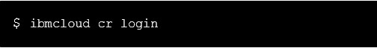

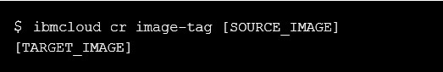



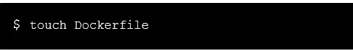



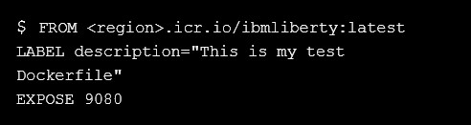

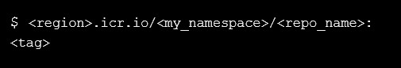

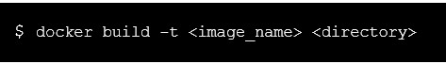





# Deleting images from your private repository in the CLI

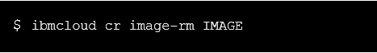

**To list the images in the trash, complete the following steps**



**Restoring images**



